**[Day 6 (03rd Feb'22) - Static vs Reference types, Encapsulation & Inheritance](https://learnifyme.ialabs.co.in/course/view.php?id=19" \l "section-6)**

**Khushi Agrawal**

**Java batch1**

**SESSION 1**

1. Print default values of static & instance variables for different data types.

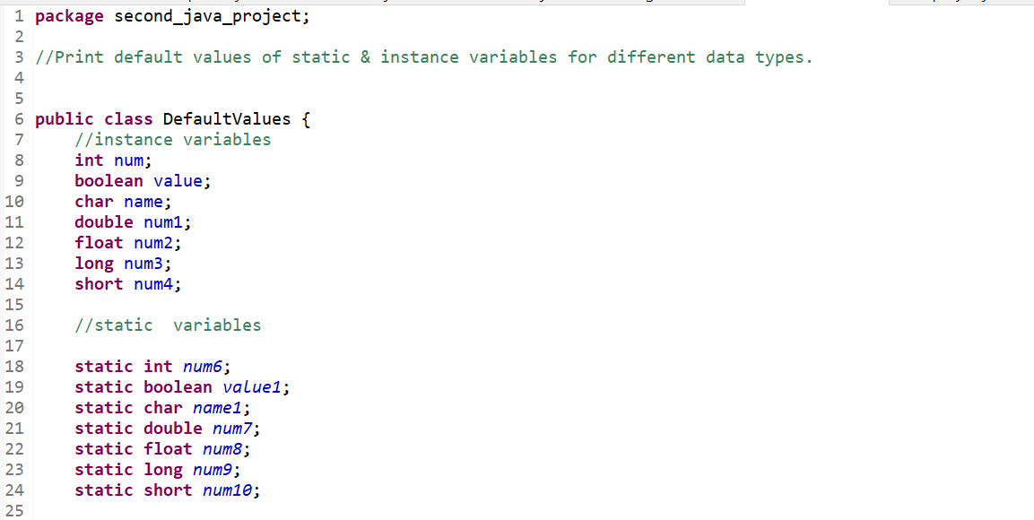

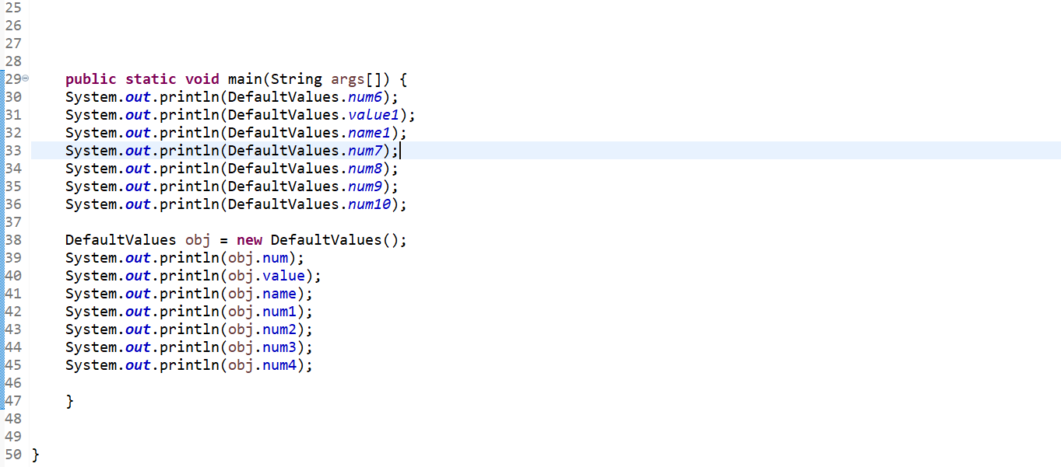

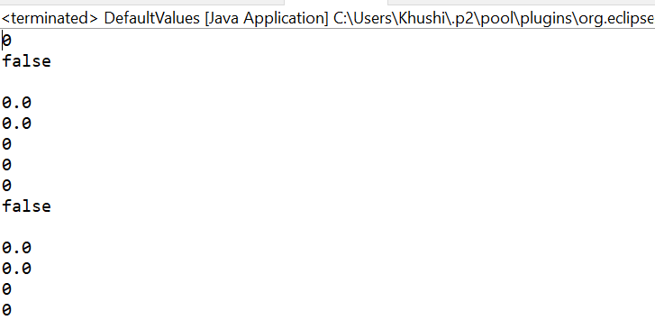

1. Build a class Employee which contains details about the employee and compile and run its instance.

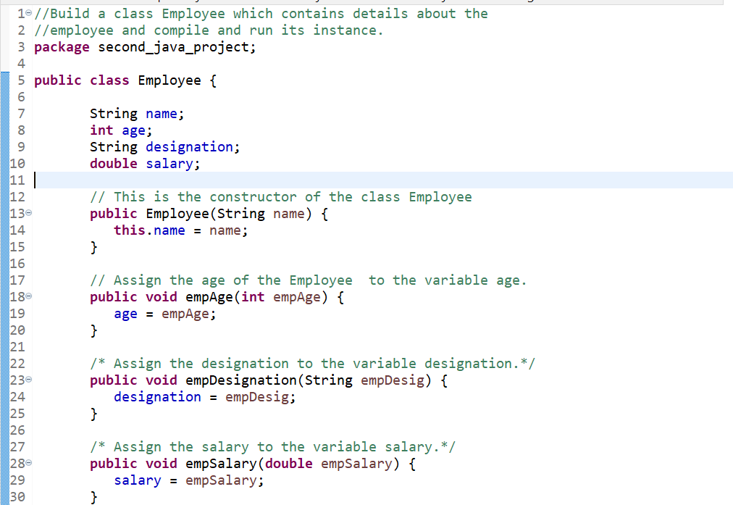

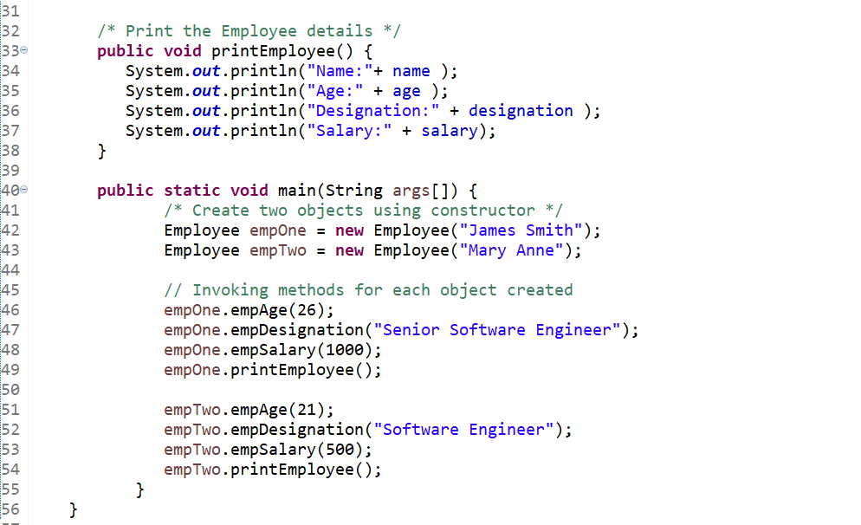

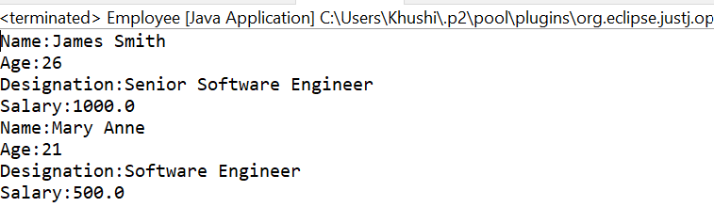

**SESSION2**

1. Create a class Vehicle and encapsulate the data members.

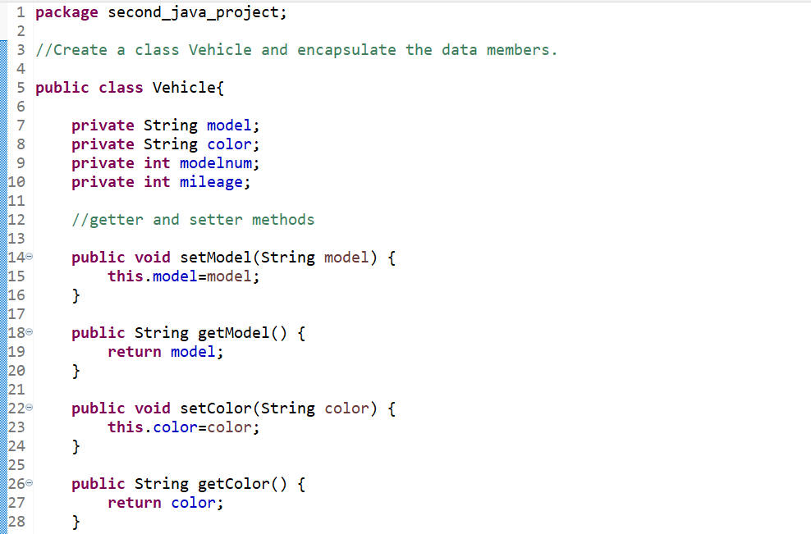

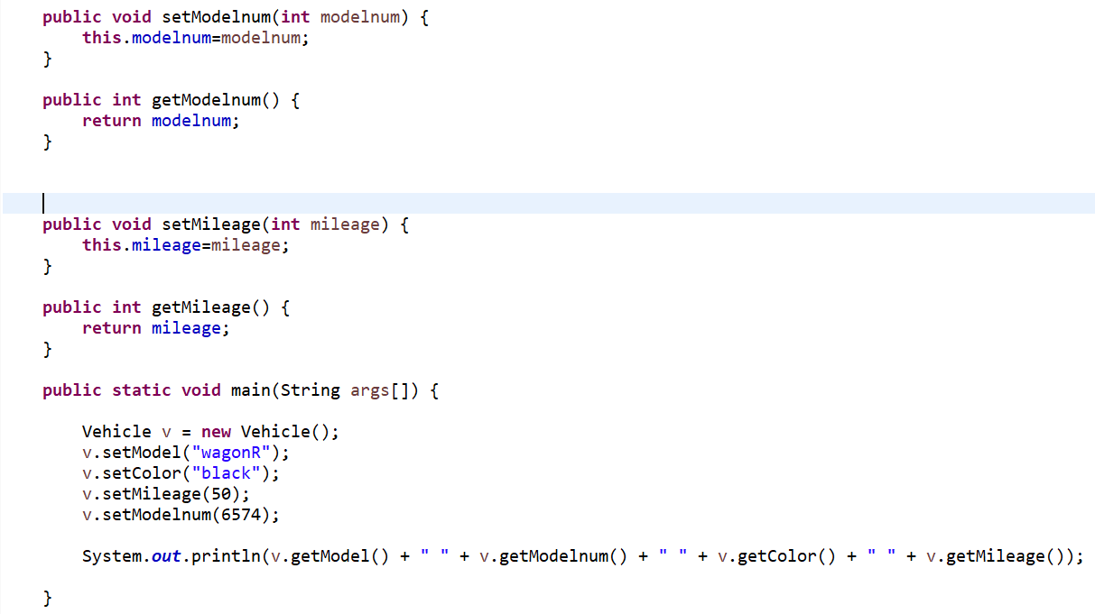

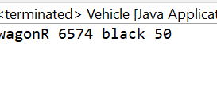

1. Create one Animal class(superclass), Dog class(subclass) the same method in the subclass override the method in the superclass.

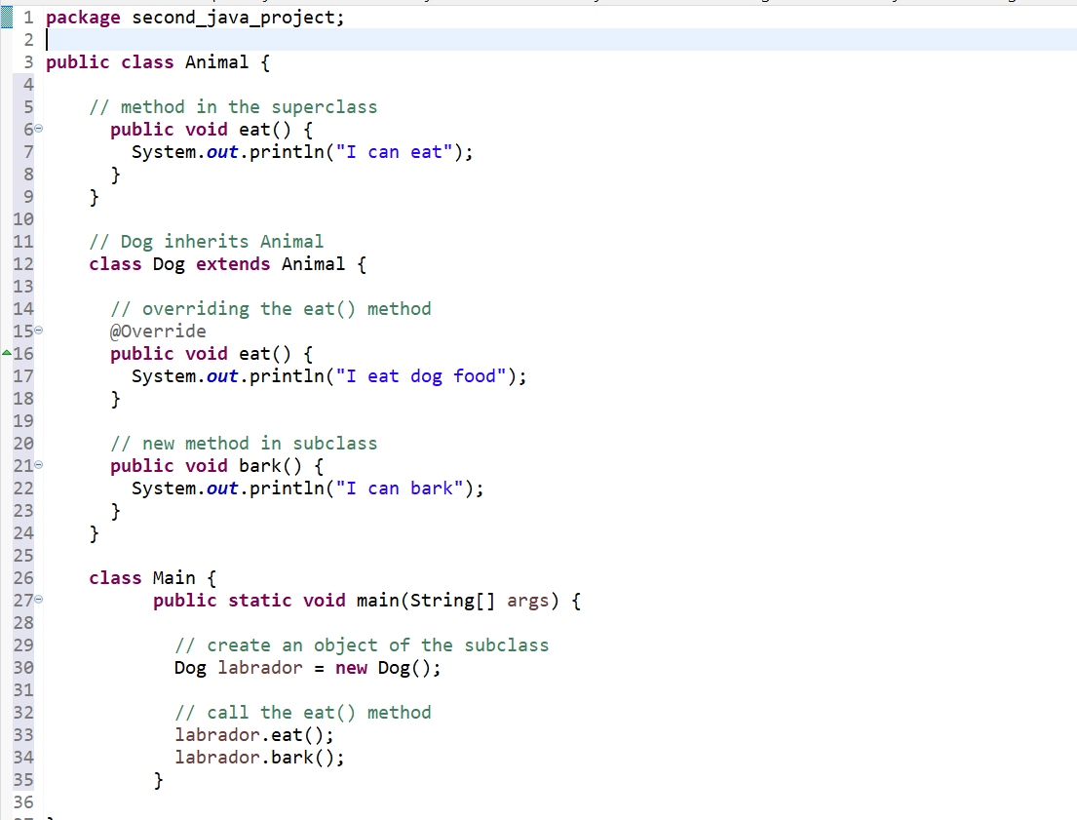

1. Create demo applications to illustrate different types of inheritance.

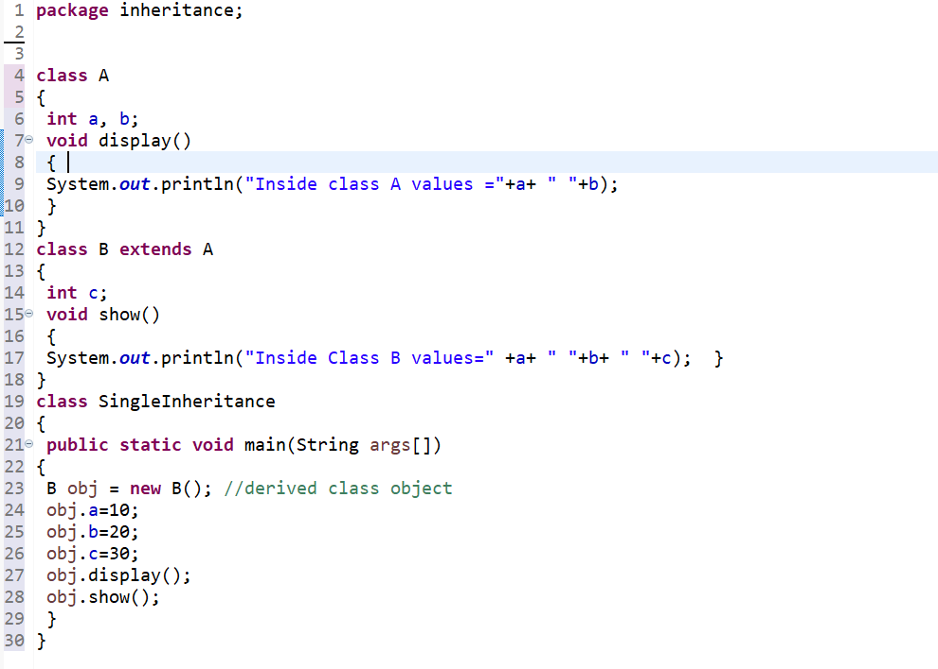

MULTILEVEL INHERITANCE

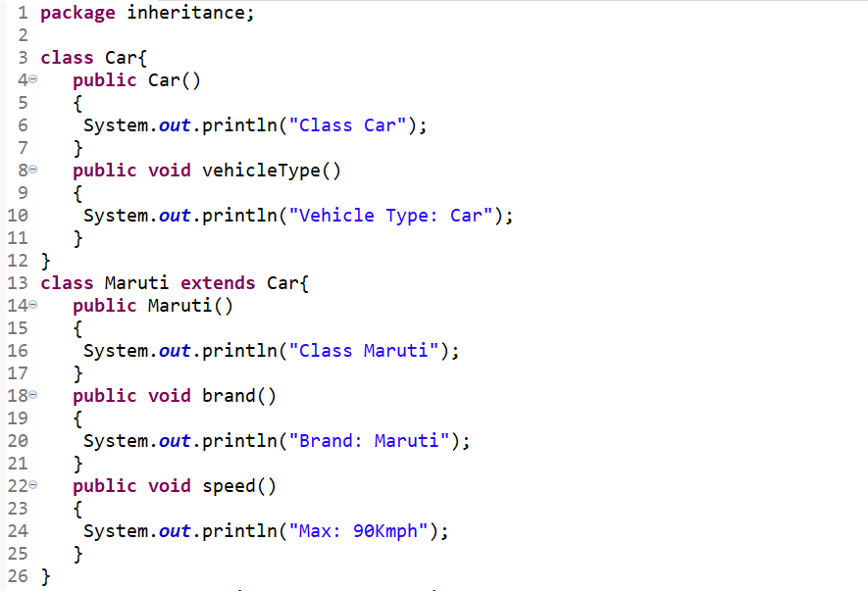

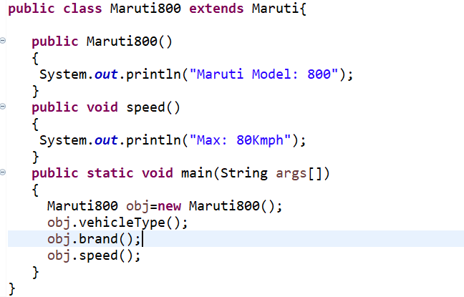

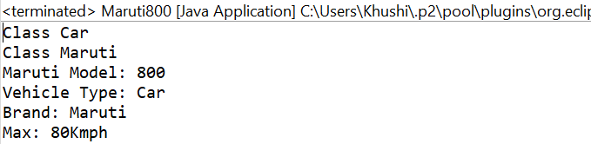

**Hierarichal inheritance**

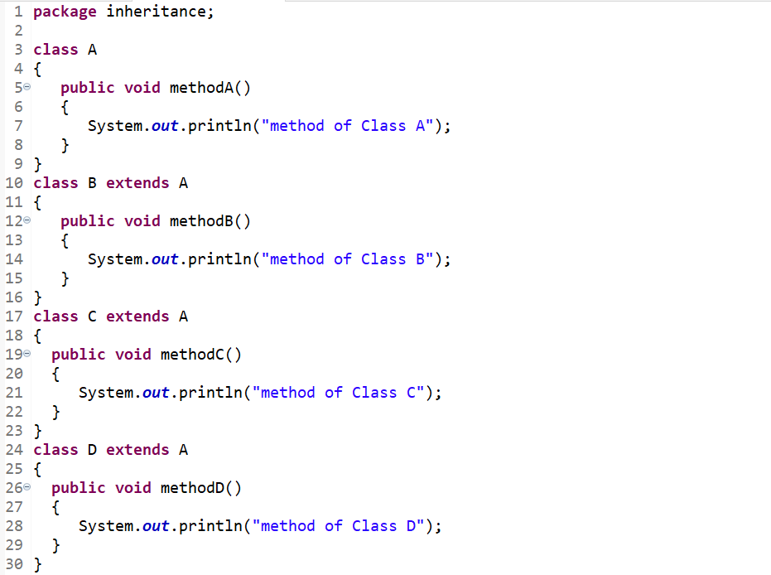

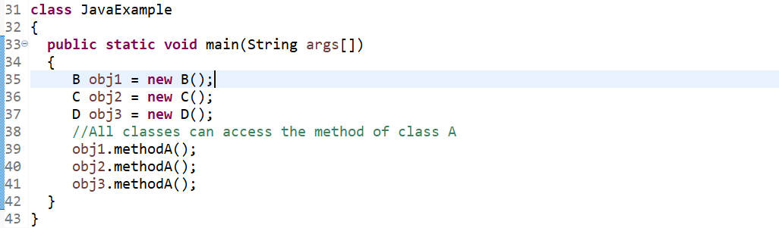

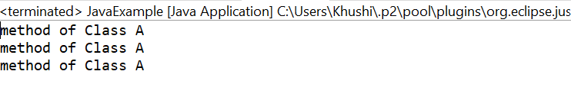

**Hybrid inheritance**

